

Single Cycle Maintenance Plan
Document Control

Prepared by:
Version | Date | Name
1.0 | 01/29/2025 | ARPITA CHANDRAKANT ZOPE
2.0

Reviewed by:
Version | Date | Name
1.0

Reference Documents

The following section describes relevant documentation:
Document Name | Description | Sharepoint Link
MAINTENANCE PLAN | SINGLE CYCLE MAINTENANCE PLAN

Contents

1.OVERVIEW: 4
2.Use case Examples: 4
3.Steps to Create Maintenance Plan: 4

1.OVERVIEW:
A Single Cycle Maintenance Plan in SAP is a straightforward maintenance scheduling plan where maintenance tasks are performed at regular, fixed intervals (cycles) based on time or performance (e.g., kilometers, hours of operation, etc.). It is commonly used when the same maintenance task needs to be repeated at consistent intervals without requiring multiple cycles or conditions.

2.Use case Examples:
For a motor in a production facility:
- A lubrication check is required every 30 days.
- A Single Cycle Maintenance Plan is created with a cycle duration of 30 days.
- Each cycle automatically generates a maintenance order or notification.

3.Steps to Create Maintenance Plan:
- Open the SAP GUI and enter transaction code IP01. Create Maintenance Plan Initial Screen will appear.

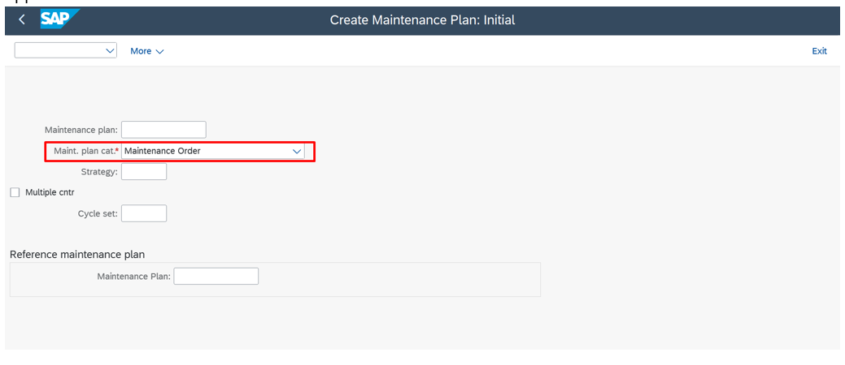

- Enter the Maintenance Plan description and Cycle, Unit, Cycle Description.

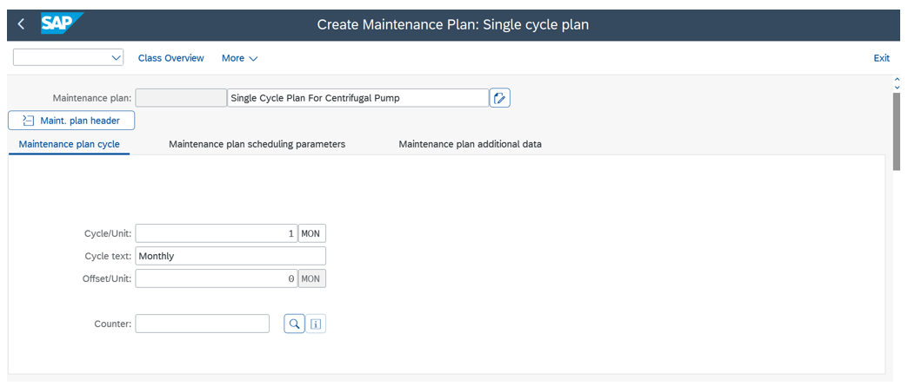

- In item tab, enter the description, Equipment. In Planning data tab, planning plant, order type, work center, Maintenance activity Type.

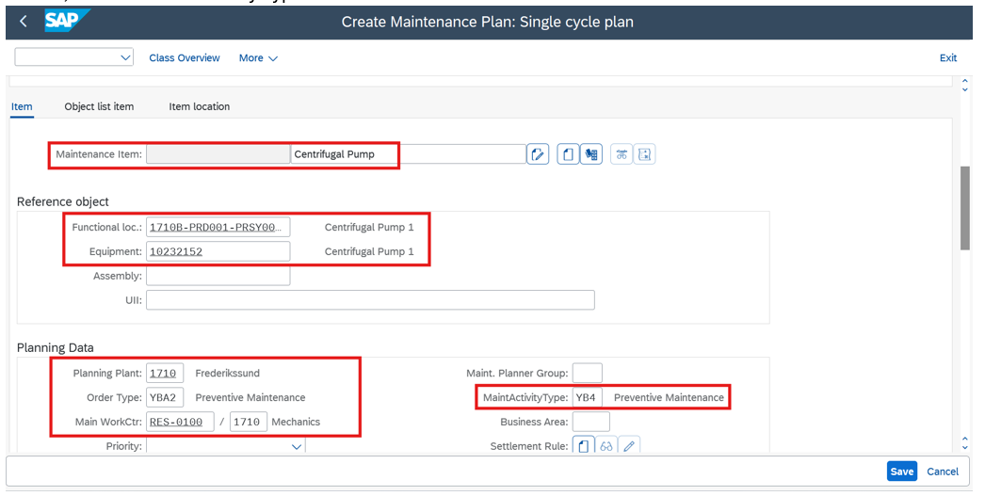

- Enter the task list type and Task list Group or Extras > task list selection > General and you can choose task list.

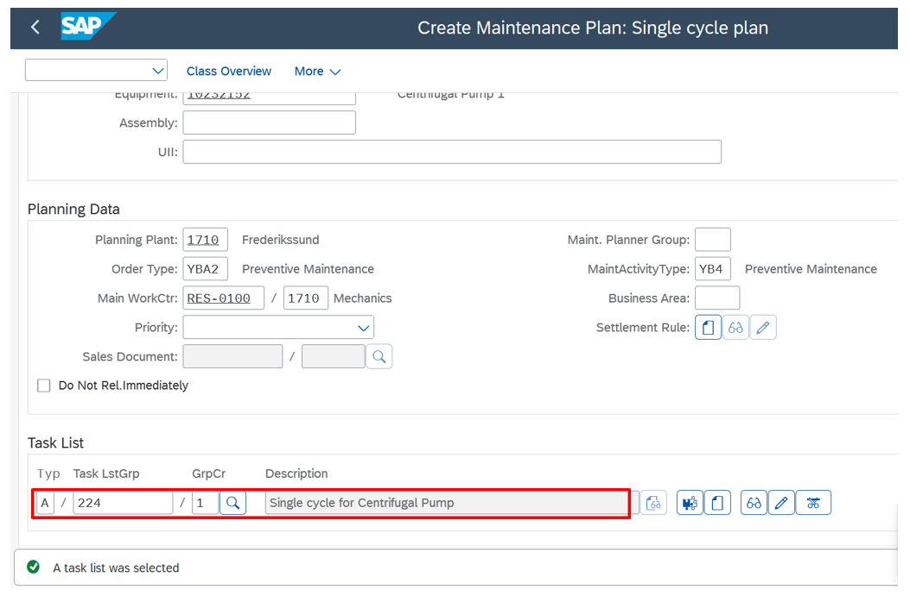

- In Maintenance Plan Scheduling Parameters Tab, enter the details. Then Click on save.

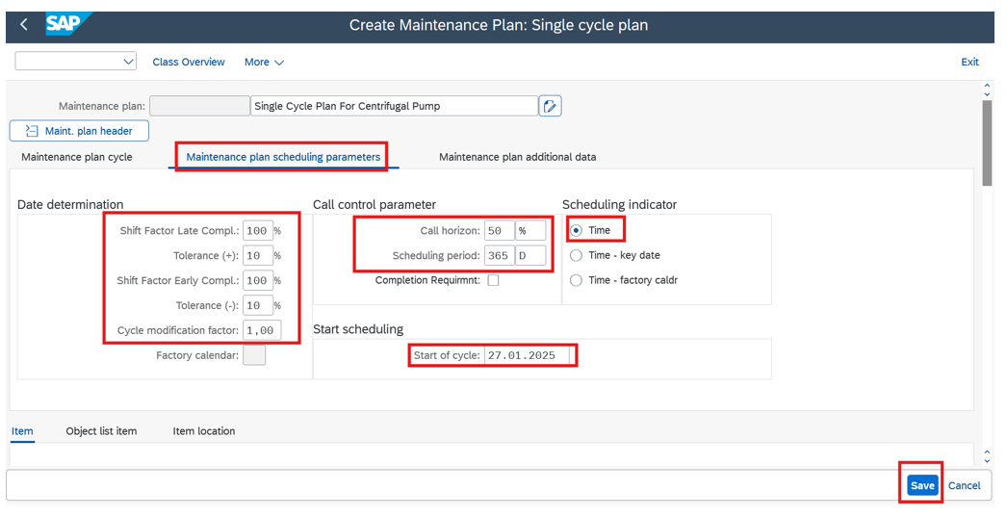
- Maintenance Plan created Message will appear.

